ORDINANCE AND RESOLUTION FACT SHEET

CADDO PARISH COMMISSION

TITLE
ORDINANCE AMENDING THE 2024 BUDGET OF ESTIMATED REVENUES AND EXPENDITURES FOR THE RIVERBOAT FUND

(Ordinance No. 6435 of 2024)

ORIGINATING DEPARTMENT: Appropriations Committee

BACKGROUND INFORMATION: Amending the budget of Estimated Revenues and Expenditures for the Riverboat Fund by $15,000 to provide an appropriation for Compassion for Lives
KEY STAFF CONTACT: Hayley Barnett

AUTHORIZATION
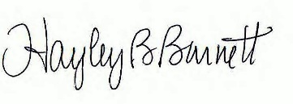

Department Head Date 5/23/24

Legal Date

Parish Administrator Date

