MINUTES OF THE SPECIAL SESSION OF
THE CADDO PARISH COMMISSION
HELD ON THE 15th DAY OF APRIL, 2024

The Caddo Parish Commission met in a Special Session, on the above date, at 2:30 p.m., in the Government Plaza Chambers, 505 Travis Street, Shreveport, with Mr. Young, presiding, and the following members in attendance constituting a quorum: Commissioners Atkins, Cothran, Epperson, Gage-Watts, Lazarus, Thomas, G. Young, and J. Young (8). ABSENT: Commissioners Blake, Burrell, and Kracman (3). VACANT: District 6 (1).

The invocation was given by Captain Jones, and Schoolboard Member Mary Trammell led the Commission in the Pledge of Allegiance.

There being no Agenda Additions or Citizens Comments, the Commission moved onto the New Business.

SWEARING IN CEREMONY OF DISTRICT 6 COMMISSIONER, STEFFON D. JONES

Judge Ree Casey-Jones swore in newly elected Caddo Commissioner, Steffon D. Jones.

At this time, Mr. Jones took his seat as Caddo Commissioner- District 6. Mr. J. Young introduced the members of the audience and congratulated Mr. Jones.

Mr. Jones thanked the Commission and his constituents for the opportunity to serve Caddo Parish once more. Let’s get to work, he said.

There being no more business to come before the Commission, the meeting was adjourned
at 2:44 p.m.

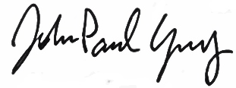

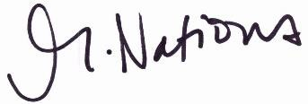
Michelle Nations John-Paul Young
Assistant to the Commission Clerk President

