RESOLUTION OF RECOGNITION AND APPRECIATION
To The
STATE DIVISION III CHAMPION CALVARY BAPTIST CAVALIERS

WHEREAS, the Caddo Parish Commission continues to observe with a growing sense of awe and admiration the annual demonstrations of gridiron prowess exhibited by the football teams fielded by Calvary Baptist, as their achievements reflect great honor and pride upon Caddo Parish; and

WHEREAS, the Calvary Baptist Cavaliers have now earned the school’s 4th State Division III Football Championship by defeating the St. Charles Catholic in the Caesar’s Superdome in New Orleans on December 9; and

WHEREAS, St. Charles came into the game with as reigning champions for the last 2 years and a 20-game winning streak, but their success and talent were not enough to best the Cavaliers who clinched 15 points in the last 3 minutes of the game to maintain their perfect record in state championship games of 4-0; and

WHEREAS, with the win the Cavaliers expanded a legacy of football excellence that has made their name known statewide. The Cavaliers captured their 4th Division III title, their first since 2020; making this a season to remember for Coach Rodney Guin and his Cavaliers; and

WHEREAS, the hard work, sportsmanship, and perseverance displayed by the Calvary Baptist football team have brought pride and honor to our community.

NOW, THEREFORE, BE IT RESOLVED, by the Caddo Parish Commission this 4th day of January, 2024, that it does hereby express its heartiest congratulations to Coach Rodney Guin and the coaches and players of the 2023 DIVISION III STATE CHAMPION CALVARY BAPTIST CAVALIERS for their demonstrations of football excellence, and for the tremendous example they provide as representatives of their school, their City and their Parish.

ATTEST:
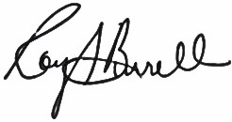

_______________________
Roy Burrell
President
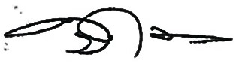
_______________________
Lyndon Johnson
District 2
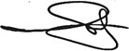
_______________________
Steffon Jones
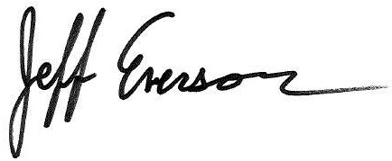
District 6
__________________
Jeff Everson
Commission Clerk

