MINUTES OF THE REGULAR SESSION
OF THE CADDO PARISH COMMISSION
HELD ON THE 6th DAY OF JUNE, 2024

The Caddo Parish Commission cancelled today’s Regular Session due to the lack of a quorum. Some of the Commissioners are out of town travelling to the NOBCO Economic Development Conference.

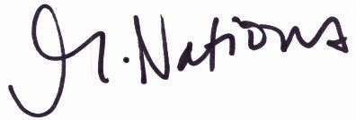
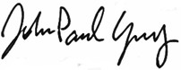

Michelle Nations John-Paul Young
Assistant to the Commission Clerk President

