MINUTES OF THE REGULAR SESSION
OF THE CADDO PARISH COMMISSION
HELD ON THE 18th DAY OF APRIL, 2024

The Caddo Parish Commission could not meet during its normally scheduled Regular Session due to challenging scheduling logistics with the City of Shreveport. The meeting was therefore held in an earlier Special Session on April 18, 2024 at 11:00 a.m.

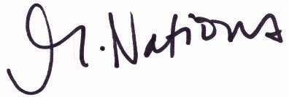
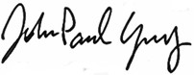

Michelle Nations John-Paul Young
Assistant to the Commission Clerk President

